This document provides a guideline to the possible users of the SkillCourt system.

SkillCourt

Player User Guide

Erico Oyarzun

Andres Ruggiero

Table of Contents

1. Introduction 1

Getting Started 2

Creating an account 3

Log In 3

As a User 4

User Account Information 6

Forget Password or Username 6

# 1. Introduction

While many areas have integrated technological advances gracefully, others lack the ability to assimilate technology with traditional techniques. Soccer is an area that has been unable to embrace technological advancements with the traditional game.

Soccer is a team-focused sport that has only one coach dedicated to the entire team, and the problem arises when players want to train & improve individual weaknesses. Moreover, the infrastructure requirements are very expensive because the need for a physical field.

For these reasons, soccer training can be a very cumbersome feat for the average person. Without proper guidance, progression dwindles and a person may not feel obligated to continue. It is essential for players to develop a body-mind coordination that allows them to move and perform specific techniques.

SkillCourt system tries to address this problem by providing players with the ability to improve their skills by interacting with it in a one-to-one manner.

The purpose of this document is to explain how the different users can interact with the new system.

# Getting Started

1. To access the SkillCourt website type the following URL in your web browser:

<http://www.skillcourt.com>

### Creating an account

As a new user, you should first create an account. The two possible actors in the SkillCourt system are players and coaches.

1. In the Main Page, click on the “Register Now” button. This should redirect you to the sign up page.

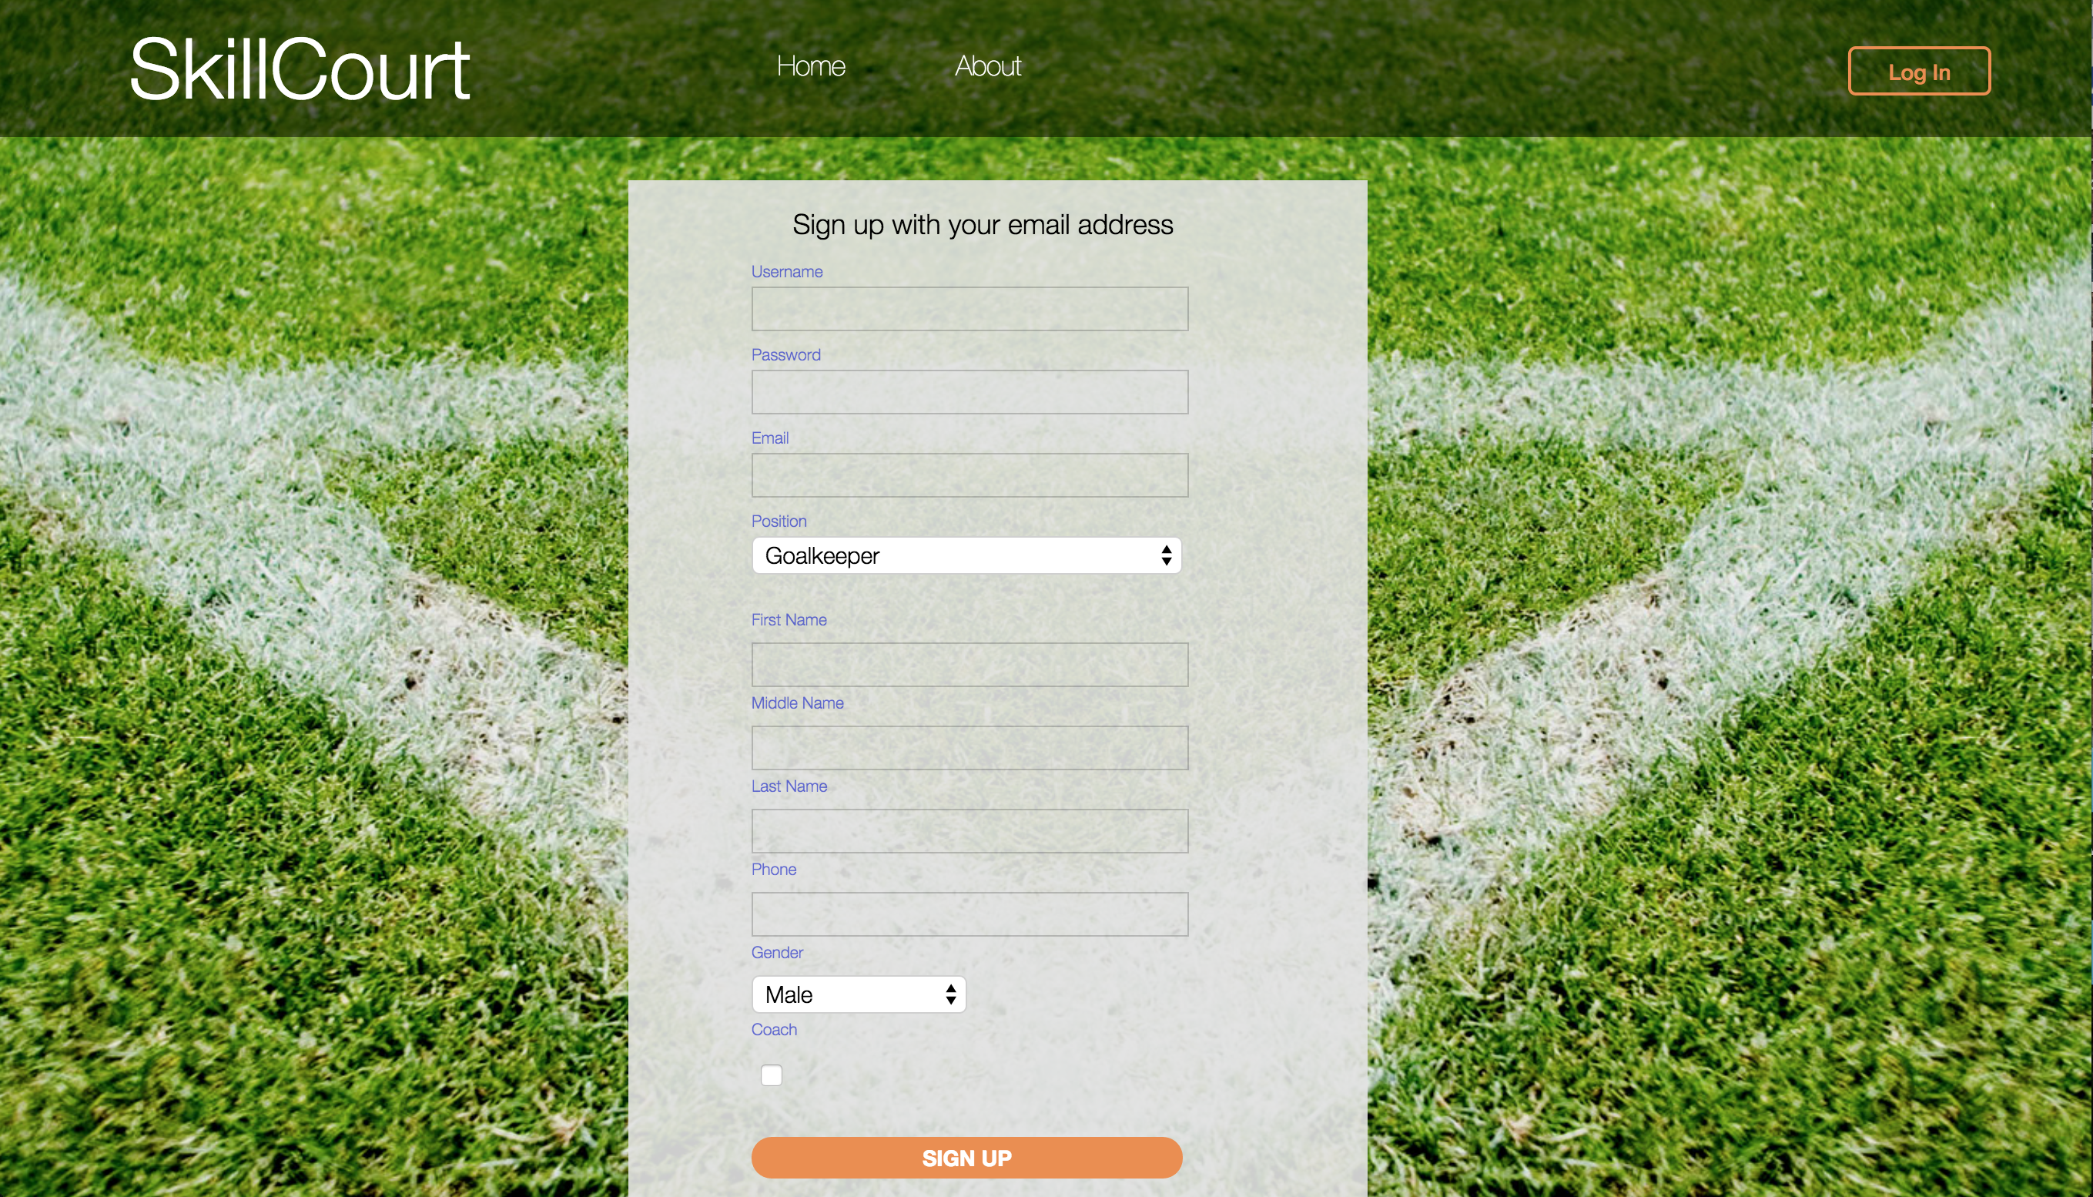

1. Fill In the proper account information. Please note that email address and username have to be unique. If you want to create a player’s account, leave the “Coach” checkbox unchecked.

# Log In

### As a User

1. In the Main Page, click the Log In button. This should redirect you to the Log In page.

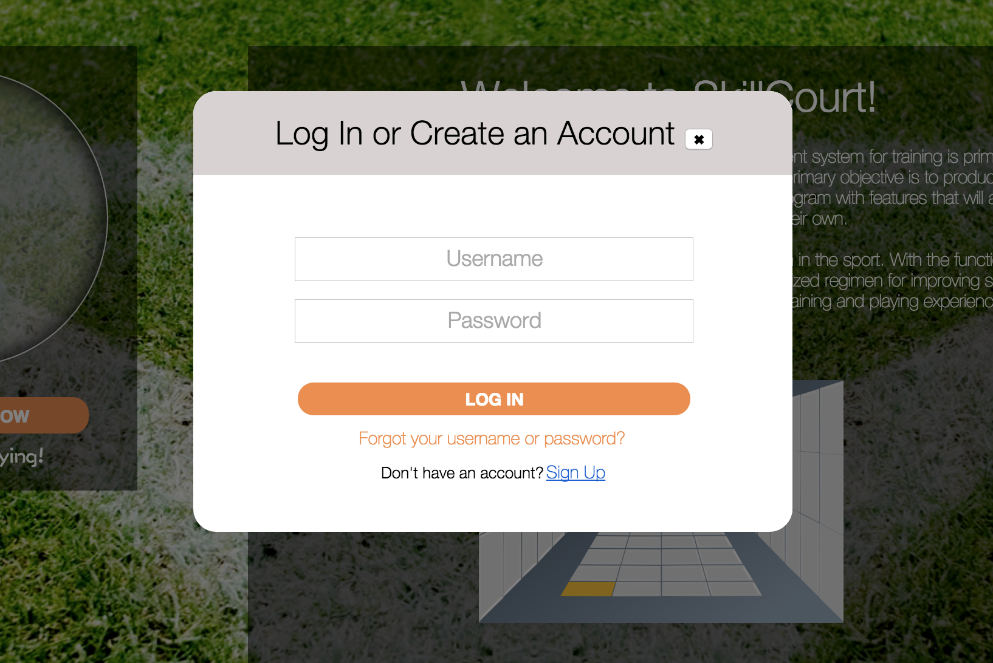

1. After creating your account and clicking the verification email in your personal email account, type in your username and password and click Log In. This should redirect you to the Player’s Home Page.
2. To play an assigned custom or default routine, click the “Routines” button in the navigation Bar. This should redirect the player to the Routines Page. Please note that a player may or may not have routines assigned.

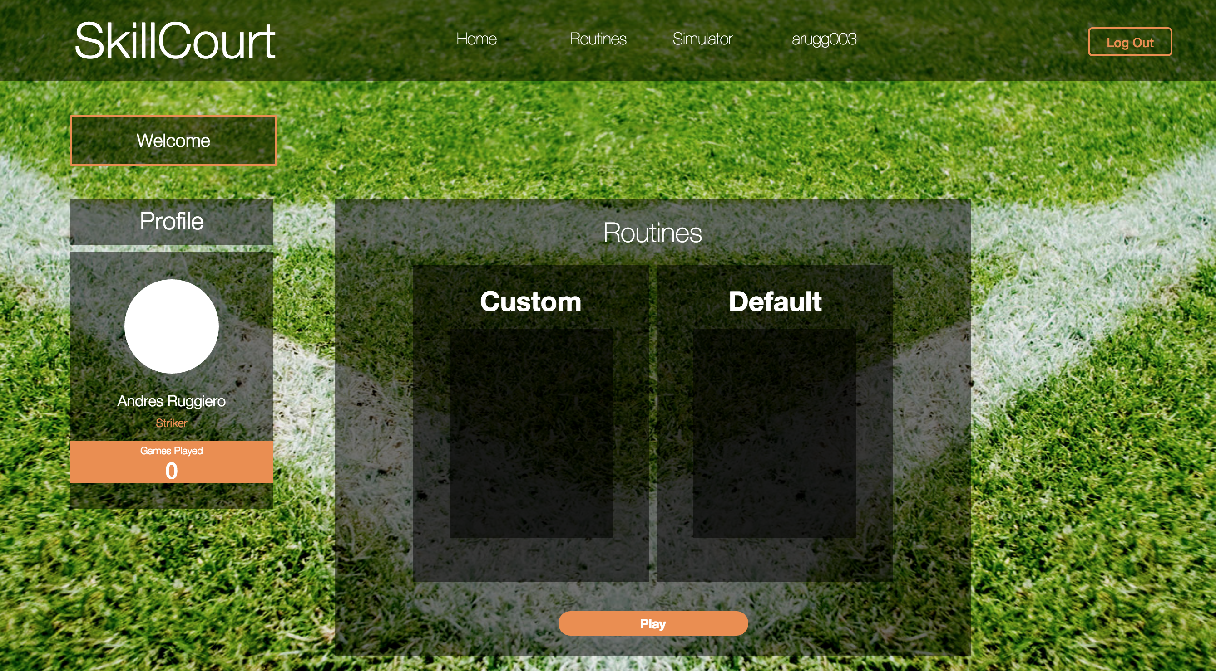

1. A new user won’t have any routines assigned. If you have routines assigned, select one from the list and click the “Play” button.
2. The third button in the navigation bar provides the ability to use the Simulator on the website. Click the Simulator button. The website should redirect the player to the simulator page.

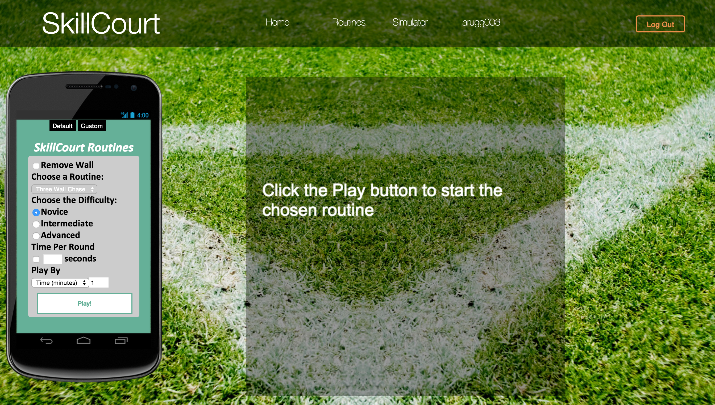

1. To play a routine select the desired routine, difficulty and type of game (by time, rounds or timed rounds) and click the “Play!” button.

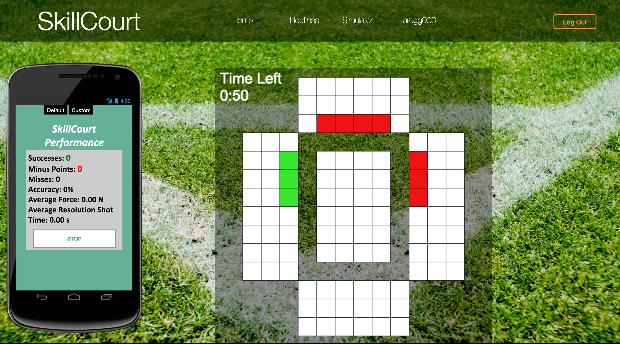

# User Account Information

1. To view a user’s profile information, click the username button on the navigation bar. This should redirect the user to the Player Profile Page.

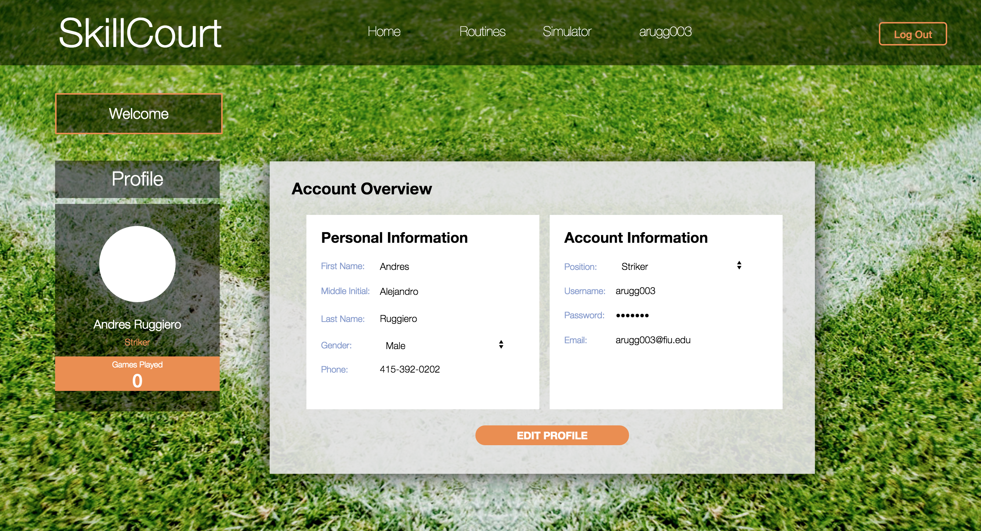

1. To edit a player’s account information, click the “Edit Profile” link. Change the information from the available fields, and click the “Save” button.

### Forget Password or Username

## Click on the Log In button on the Main page of the website. The website should redirect the user to the Log In Page.

## Macintosh HD:Users:andresruggiero:Desktop:Screen Shot 2015-07-30 at 2.17.13 PM.png

## Click on the “Forgot your username or password” link. This should redirect the user to the Reset Password Page.

## Macintosh HD:Users:andresruggiero:Desktop:Screen Shot 2015-07-30 at 3.44.16 PM.png

## Enter your email address and click the “Send” button. This should send and password reset email to your account. Click the link and reset your password